# Module 01: Understanding DevOps Culture - Part 1

Completing the steps in this exercise will require you to sign up for third party services that may incur fees. Be sure to follow proper guidelines for removing billable services from your account before you leave your lab. Deviating from our specific instructions may result in unwanted fees for services from third-party service providers. Be sure to check with your school, instructor, or employer if education accounts are available. If you sign-up and provide your credit card, you will be responsible for any fees related to services you activate. We strongly advise you not to deviate from our explicit instructions while connected to the platforms unless you are fully aware of what the services are and what the respective third-party charges for their use.

## Lab 1: Integrating Eclipse with Bitbucket for Source Code Management

*Bitbucket is a source code management service that can be integrated with Eclipse to merge and manage the source code modifications of a project.*

**Lab Scenario**

In an organization, the application source code is developed by multiple team members. In such a scenario, everyone needs to keep the source code updated with changes all the time. In this lab, you will be integrating Bitbucket repository with an Eclipse project for code management; this will help in keeping the code updated and available to everyone who has access to it.

**Lab Objectives**

This lab demonstrates the steps to integrate Bitbucket with Eclipse for managing the project.

**Overview of Bitbucket Integration with Eclipse**

Bitbucket is a source code management service, that is, it is used for managing the application source code. It gives you the option for access control, which allows you to restrict access to the code. Bitbucket allows the DevOps team to keep their source code updated with every change that has been updated by anyone in the team. Bitbucket helps the development team collaborate and maximize productivity, sparking faster delivery and increased visibility for the project. By integrating Bitbucket with Eclipse, the changes that are made in the code in Eclipse can directly reflect into the code changes in the Bitbucket repository.

**Lab Tasks**

1. Launch [On-Prem Dev](https://labclient.labondemand.com/Instructions/817769ee-5230-4dfb-94bd-919bd46d87d7#) machine and click [Ctrl+Alt+Delete](https://labclient.labondemand.com/Instructions/817769ee-5230-4dfb-94bd-919bd46d87d7#) link. Log in with Admin as user and Pa$$w0rd as password.  
   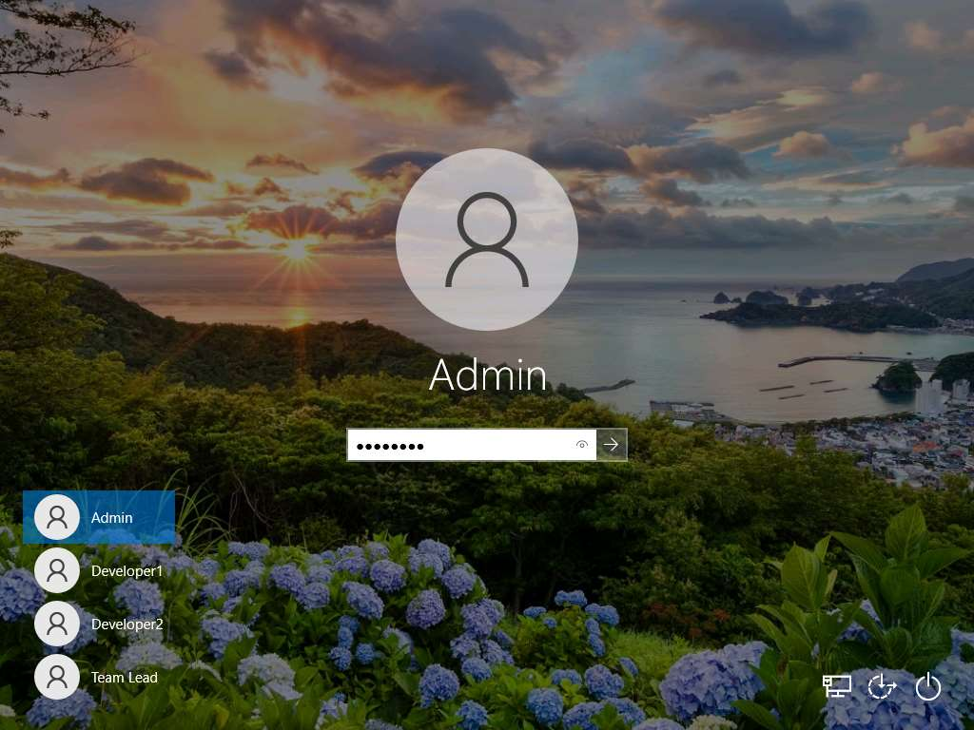  
   If you get "**Do you want to allow your PC to be discoverable by other PCs and devices on this network?**" prompt, click **Yes**.
2. To open the browser, double-click on the **Google Chrome** icon on the desktop.
3. First, we need to set up Bitbucket to integrate it with DevOps. Go to https://bitbucket.org and click on **Get it free**.  
   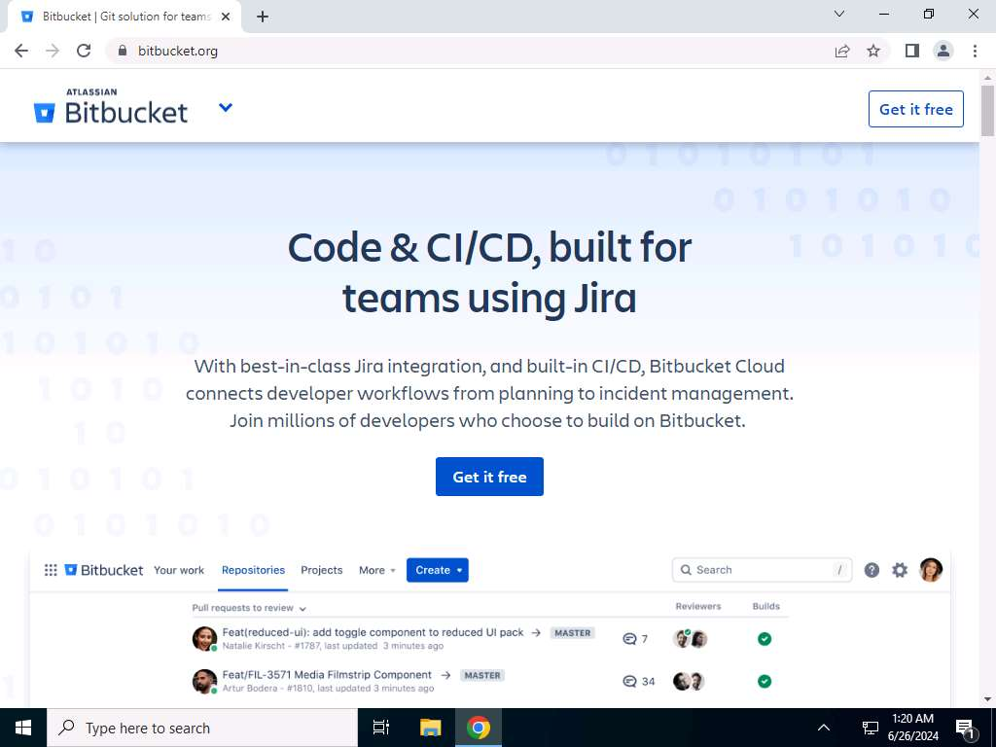
4. Sign in with any one of the options that are available, as shown in the screenshot.  
   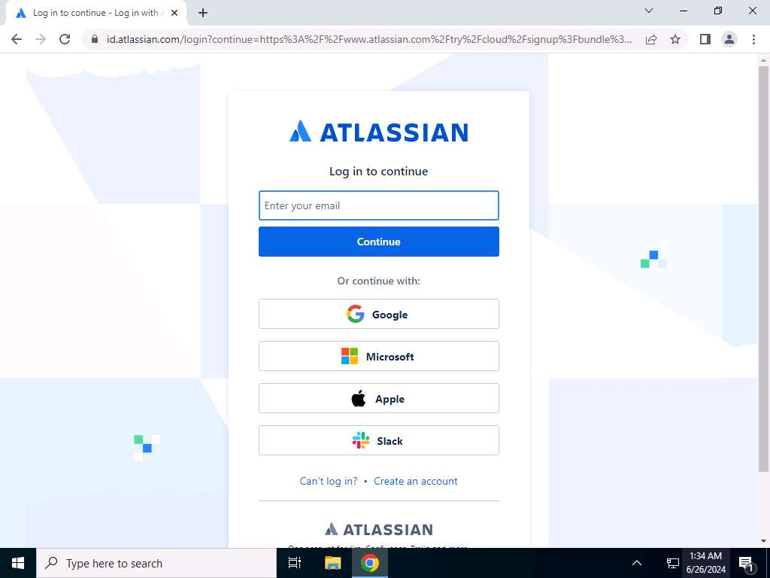  
   Sign in using your existing account. If you don't have one yet, click "Create an account" to get started.
5. If you are using a Microsoft account, enter the **email ID** and click on **Continue**.  
   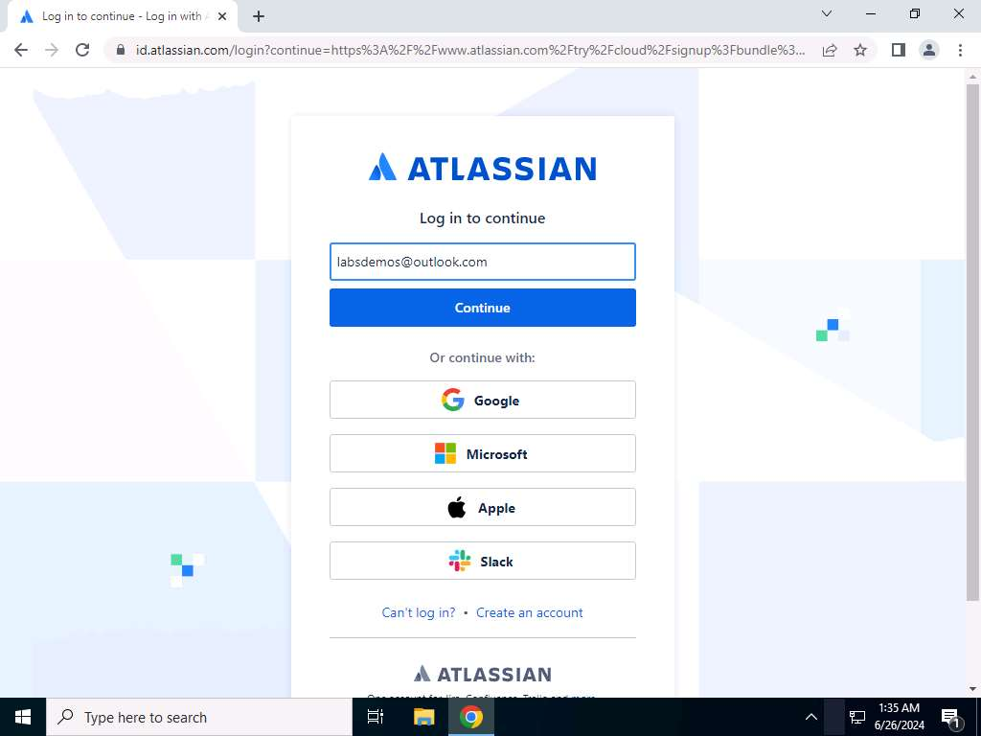
6. Enter the **password** and click on **Sign in**.  
   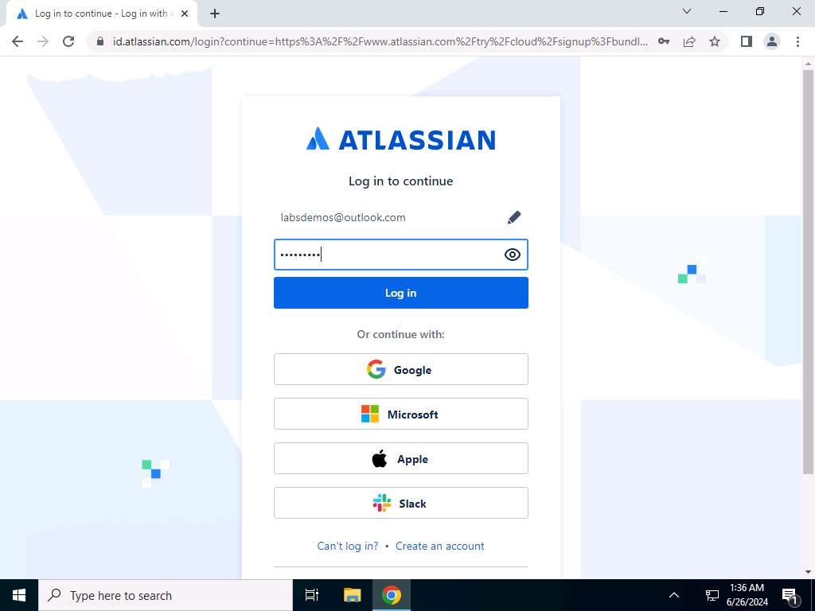
7. Next **Create a Workspace**, Type a name for your workspace in the **Workspace Name** here we are using **testdemo_ecde** and click on **Agree and create workspace**.  
   The system will assign the entered workspace name as Workspace ID. The Workspace ID should be unique, and you will get **Workspace with this Slug already exists** warning if this ID is already found. Edit the Workspace ID to a unique workspace ID before saving.  
   To access this page, you'll need a Bitbucket account. If you don't already have one, you can create one quickly and easily.  
   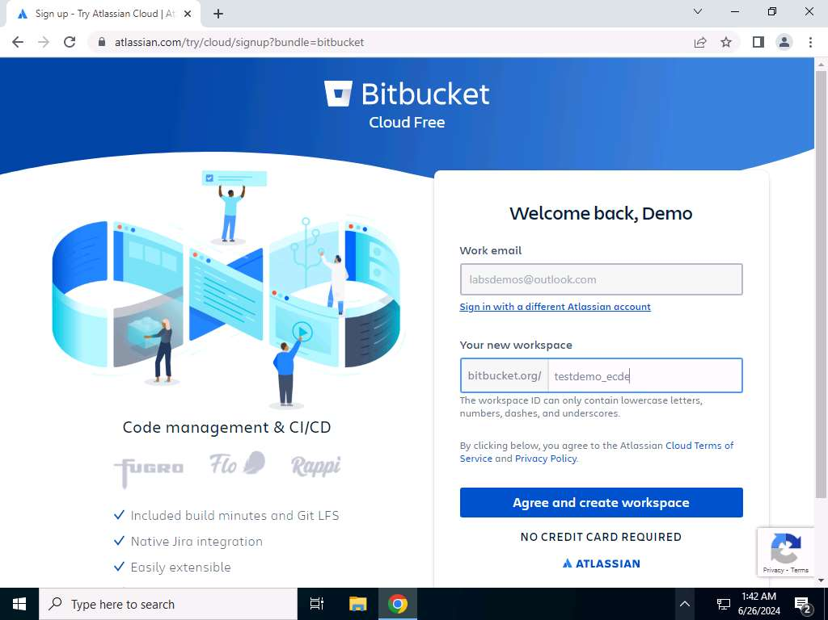 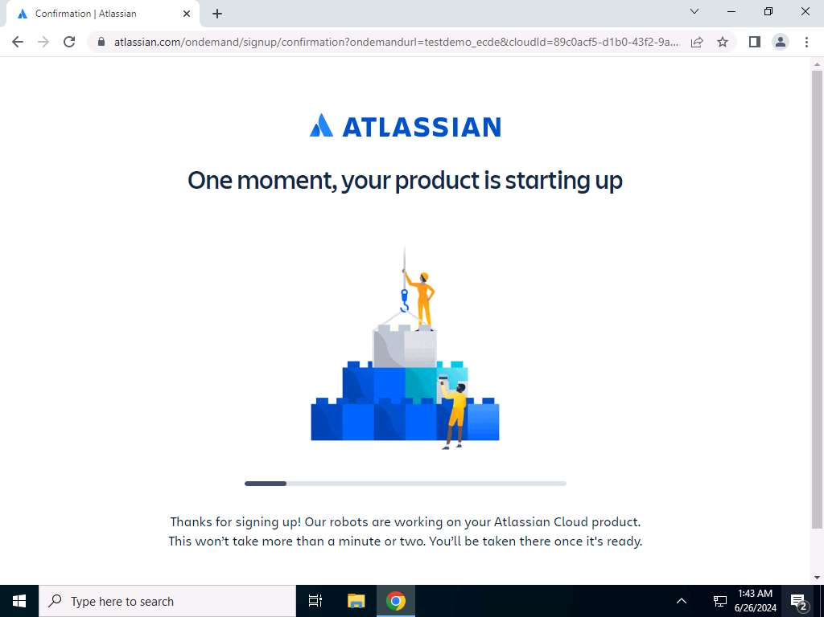
8. Now click on **Create repository** to create a basic repository with a readme file.  
   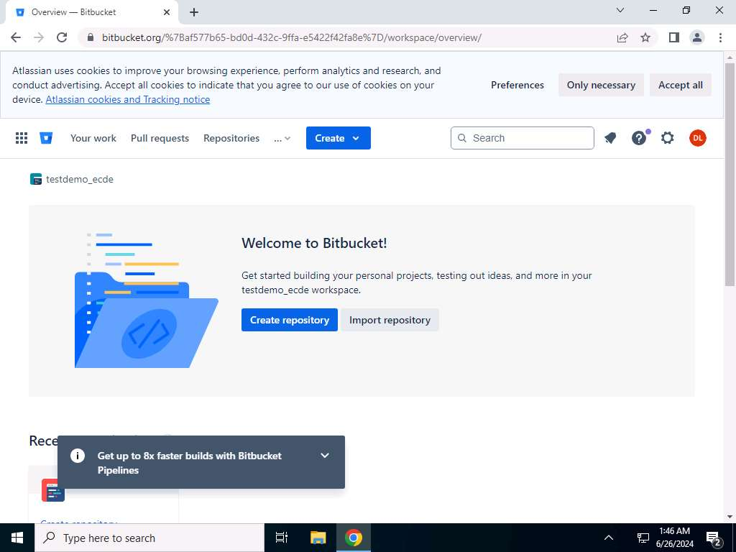
9. Type the name of the project in the Project Name field. Here we have used **DemoProject** as the project name and repository name as **WebGoat**. Click on **Create Repository**.  
   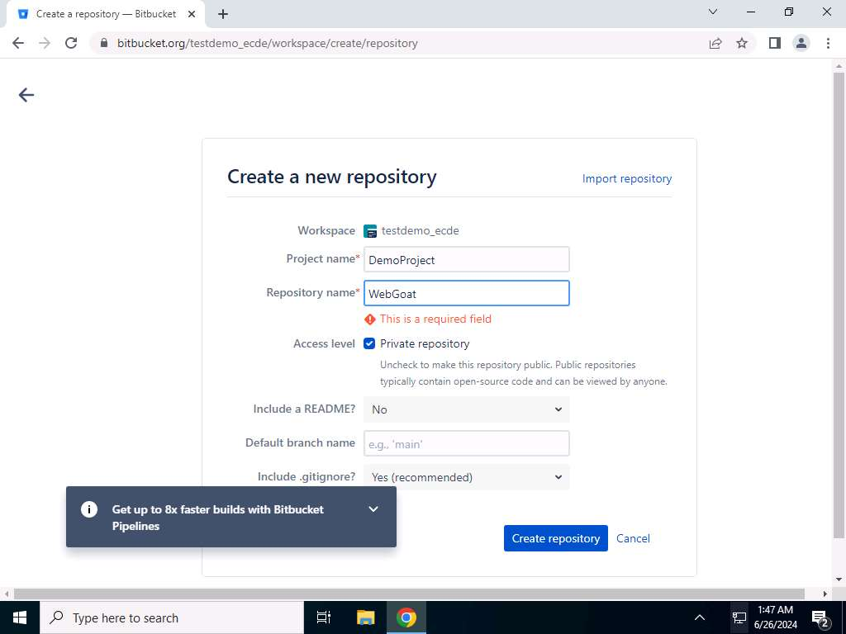 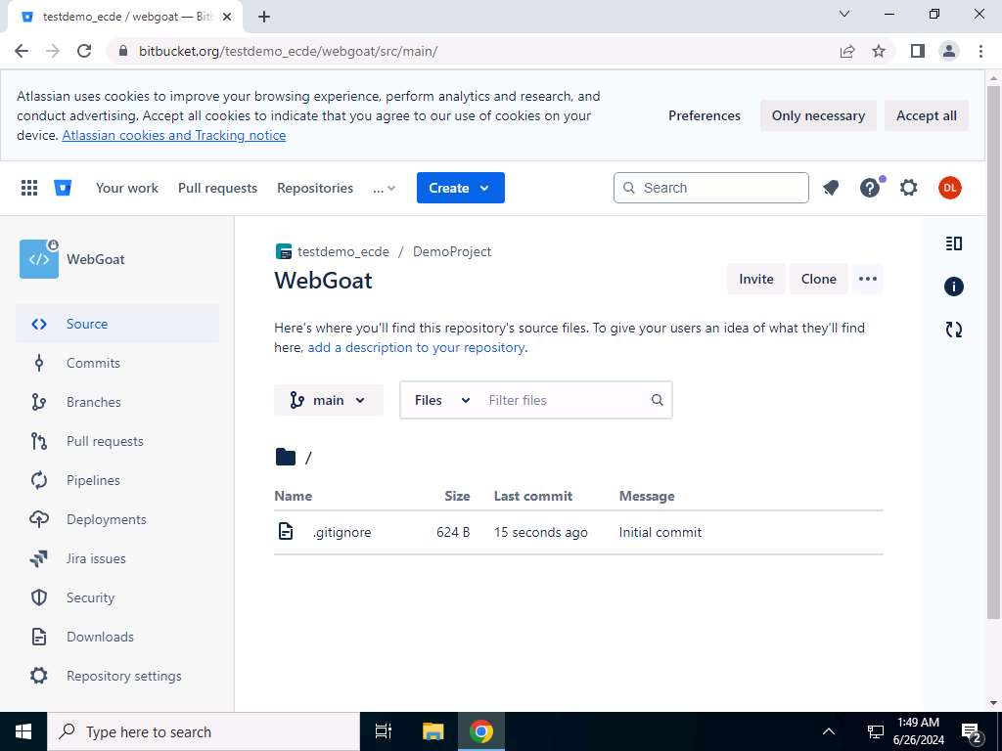
10. Double click on the **Eclipse IDE icon** to open Eclipse IDE.  
    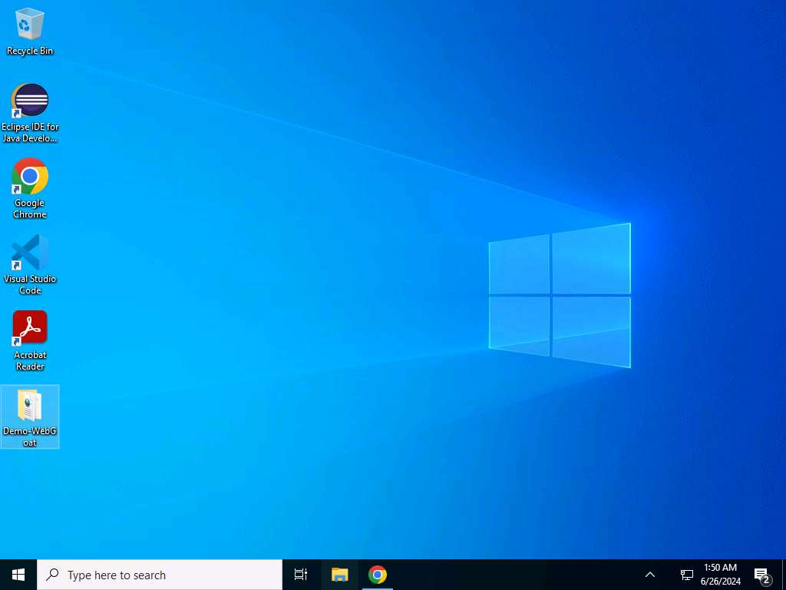
11. Now we will be opening the Web Goat project in Eclipse, which we will import in Bitbucket. Launch Eclipse IDE.  
    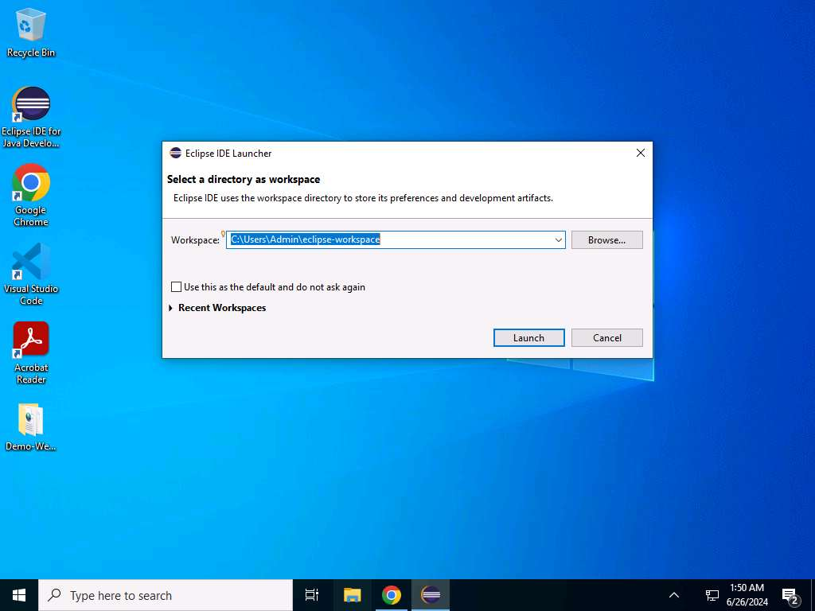
12. Now select the **File** option and click on **Open Projects from File System…**.  
    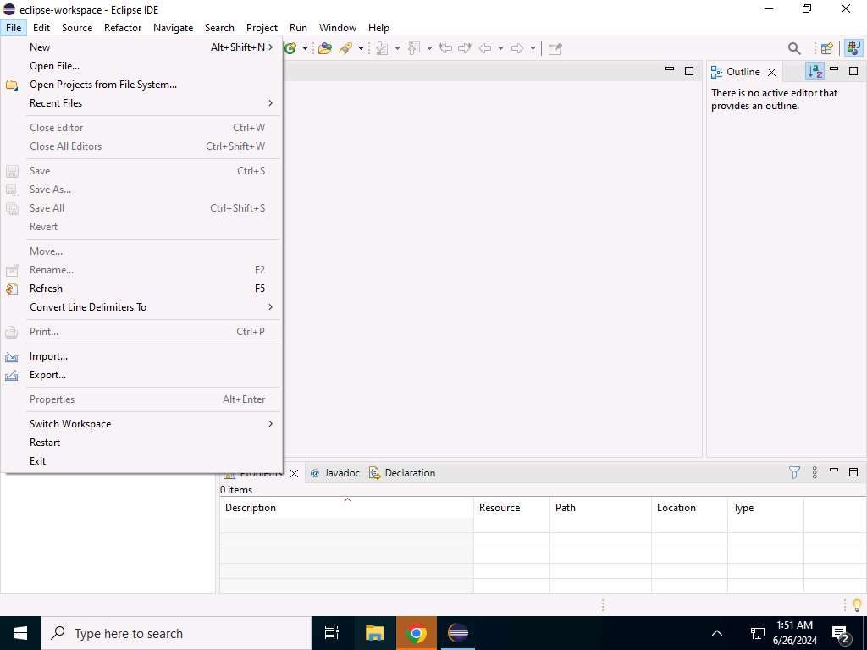
13. In the **Import source** click on **Directory**.  
    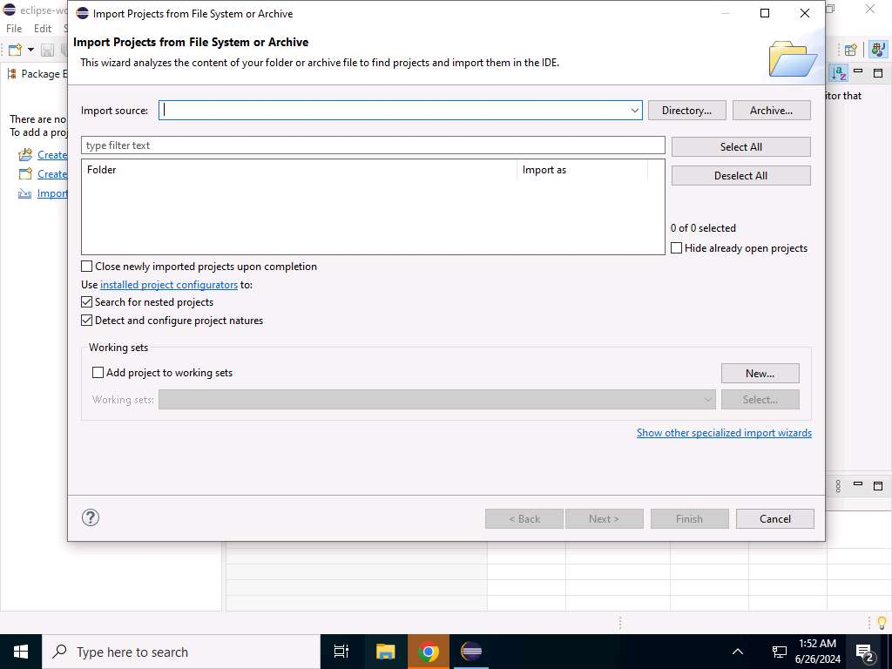
14. Navigate to **D:\DevSecOps\Files\WebGoat** and right-click on the **Demo-WebGoat** folder is located and select the project **Demo-WebGoat**. Then click on **Select Folder**.  
    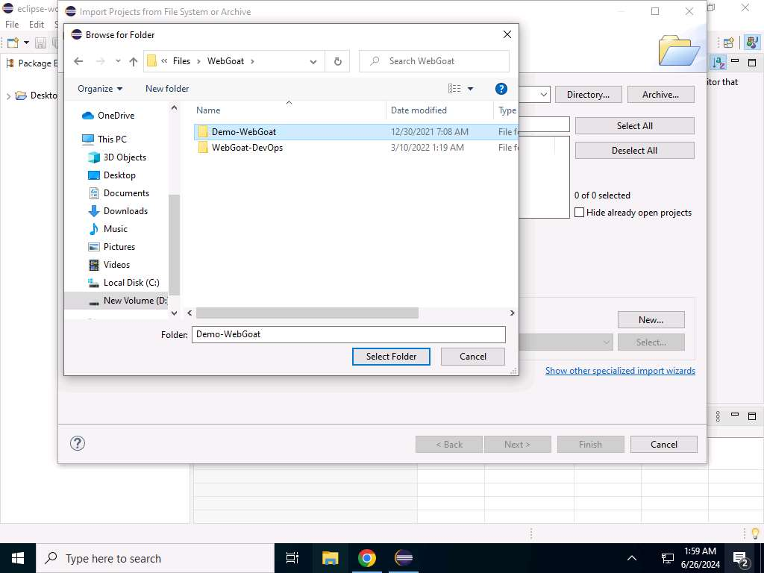
15. Now click on **Finish** to complete importing the project into Eclipse.  
    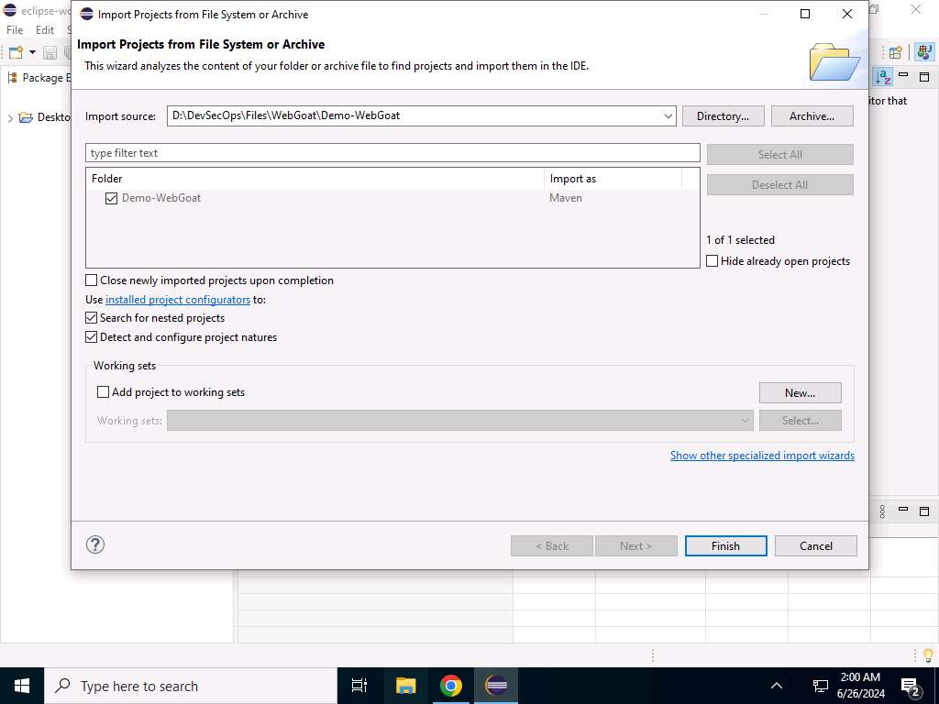
16. The project will open in Eclipse IDE.
17. Right-click on the project and go to **Team>Share Project..**16 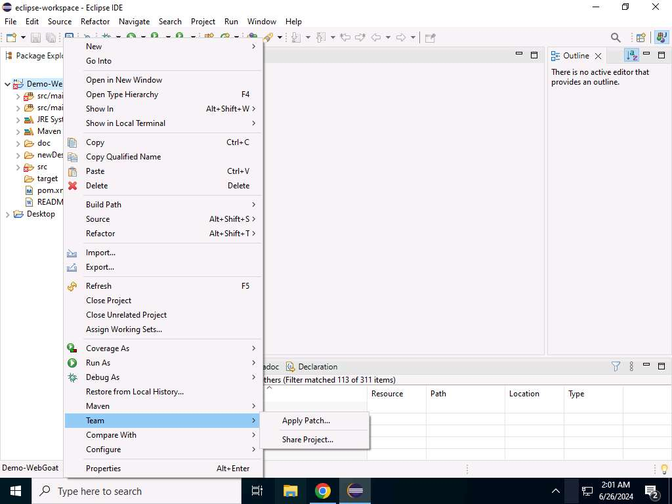
18. In the **Share Project** window, select **Use or create repository in parent folder of** **project** checkbox and click on **Create Repository** button. Then, select the project and click on **Finish**.  
    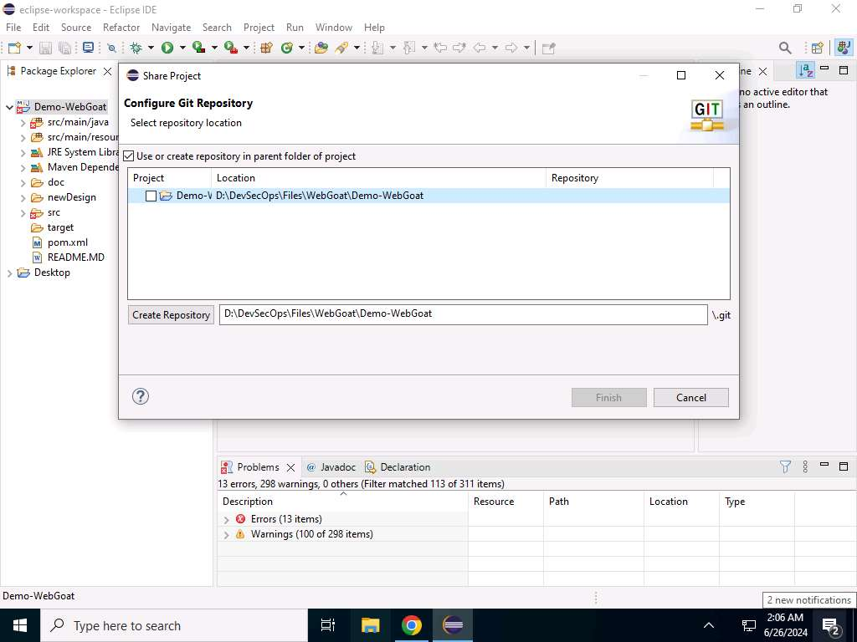
19. Then, right-click on the project and go to **Team>Commit**.  
    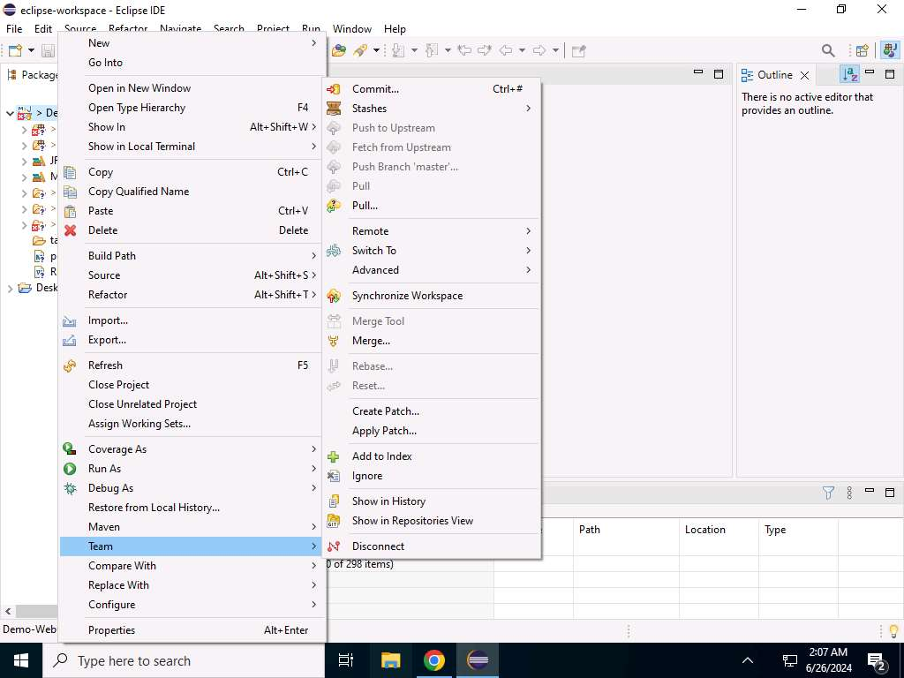
20. Click on Add all files button in the **Unstaged changes** section.  
    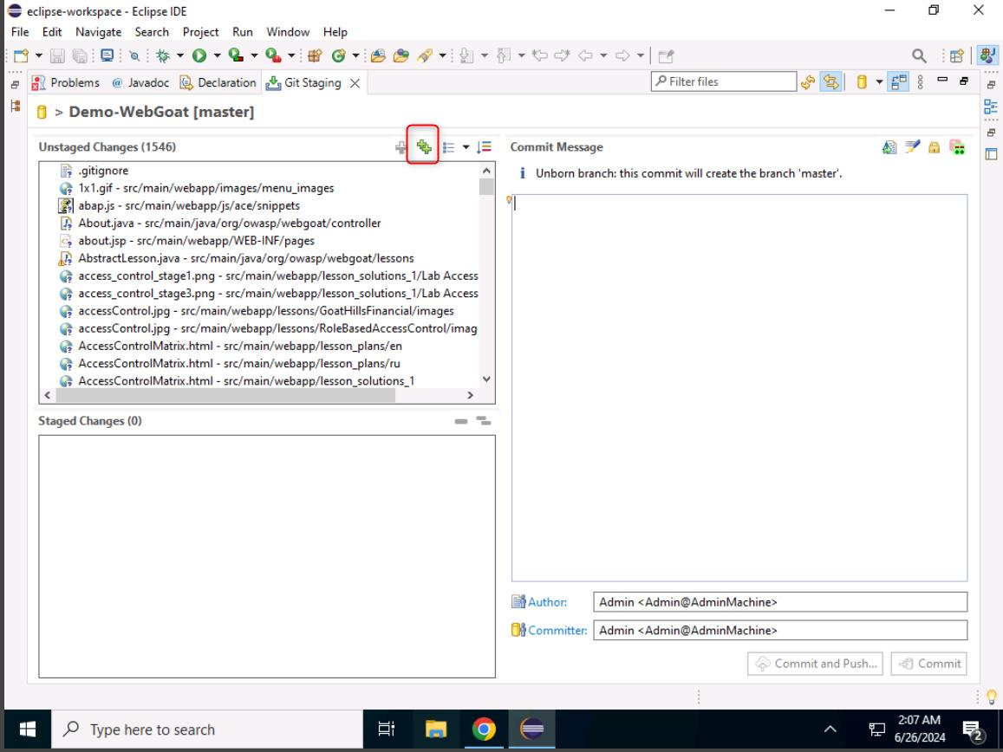
21. In the **Commit Message** box, type **First Commit** and click on the **Commit** button.  
    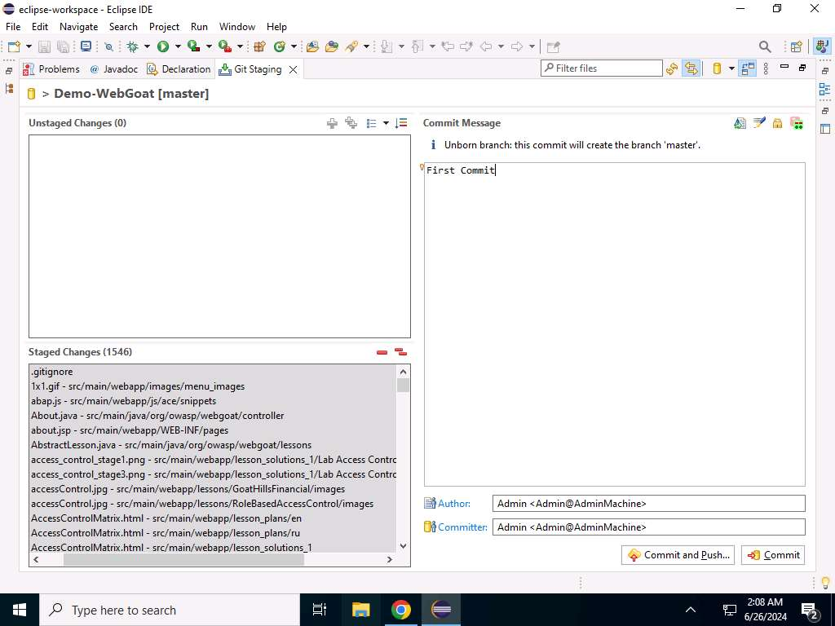
22. Now **right-click** on the project that opens in Eclipse.  
    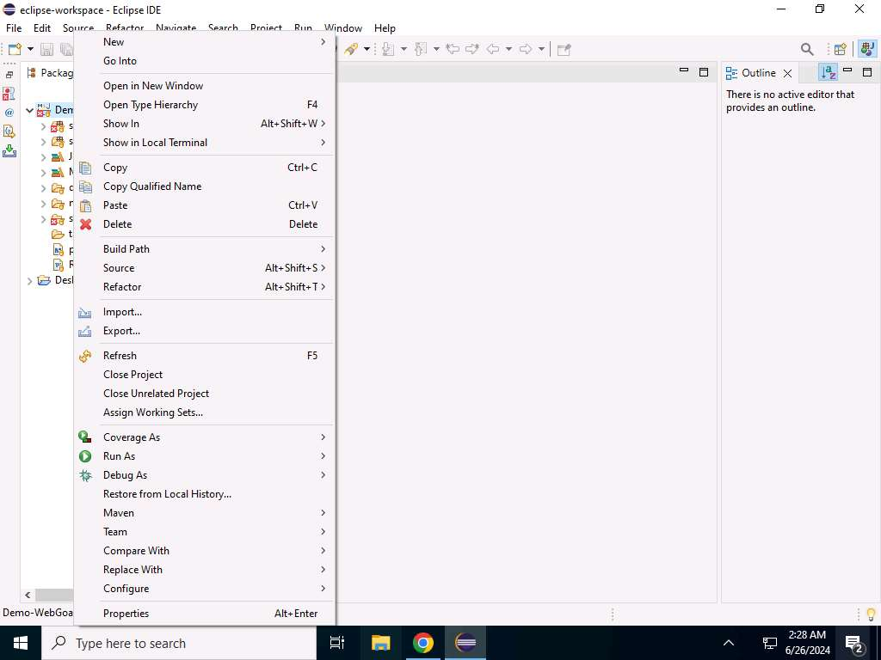
23. Click on **Team**, select the **Remote** and click on **Push**.  
    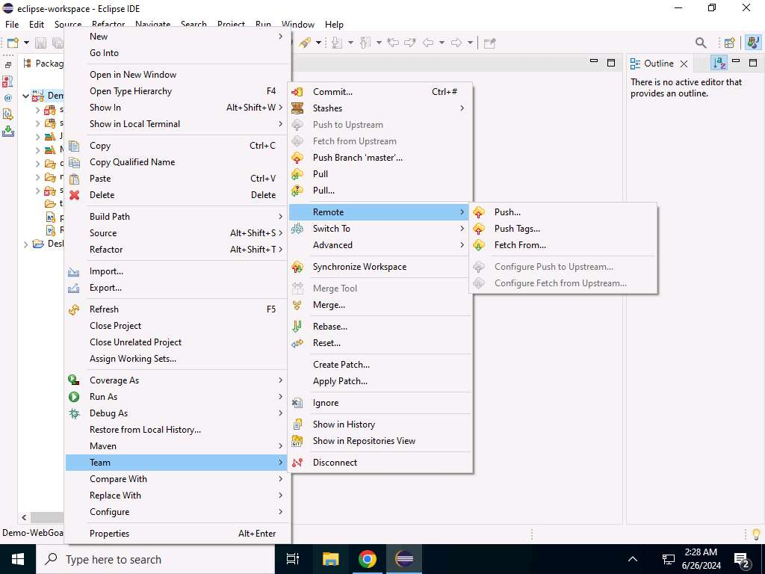
24. Now, The Destination Git Repository page will appear. Leave the window as it is.  
    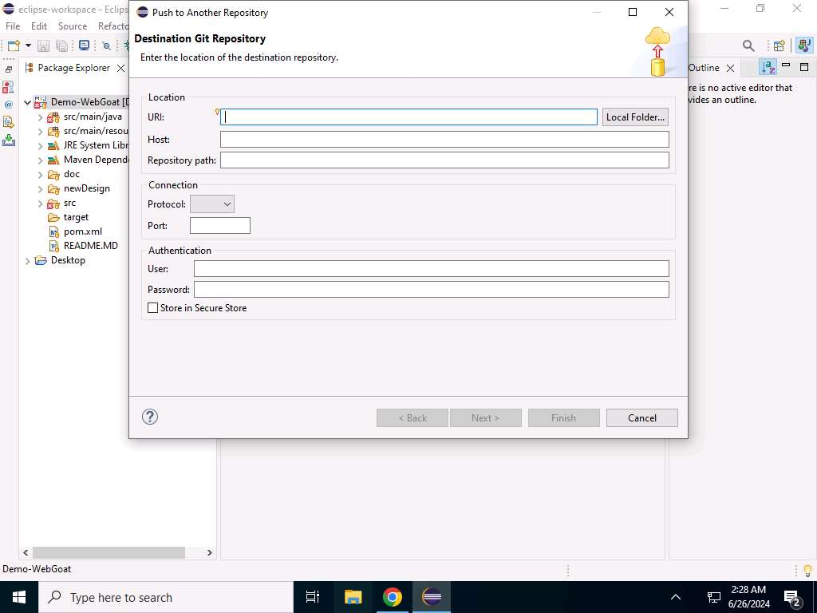
25. Now you will be generating the Git URL and a password for it. Go to the browser where Bitbucket is open and click on **Source**.  
    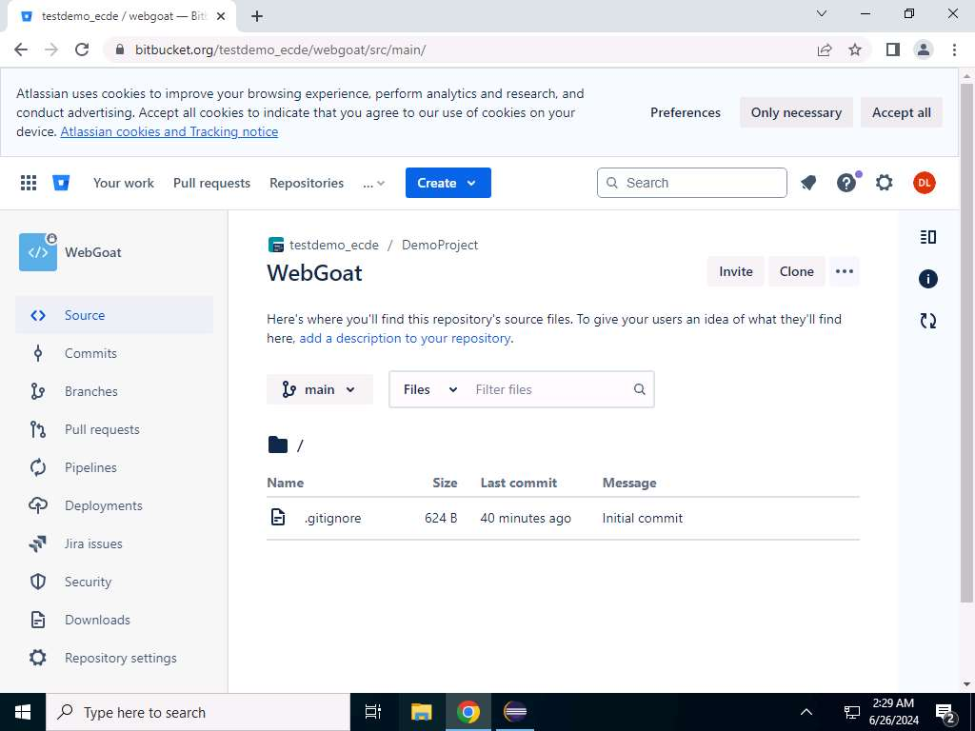
26. Click on **Clone** to generate the Git address.  
    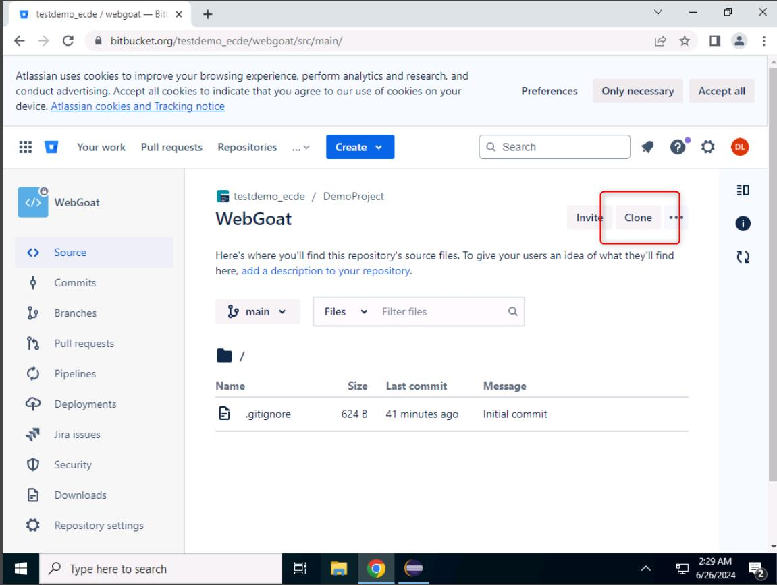
27. Copy the **Git address** to Notepad.  
    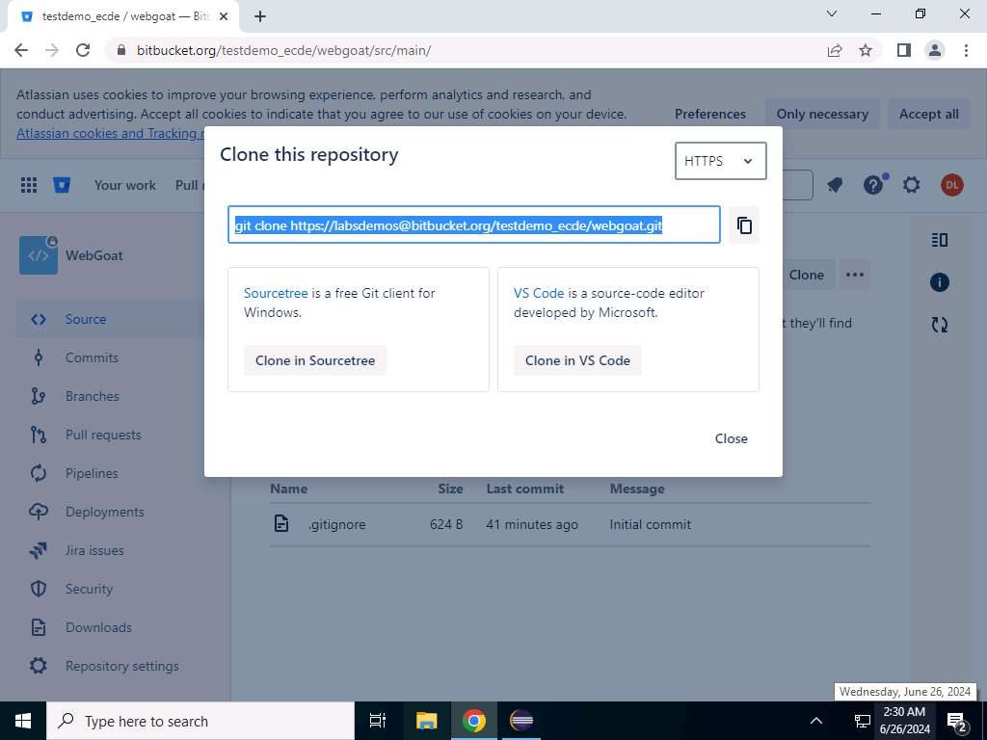
28. Click on **Settings(gear icon)** beside the **user icon** and select **Personal Bitbucket settings** option..  
    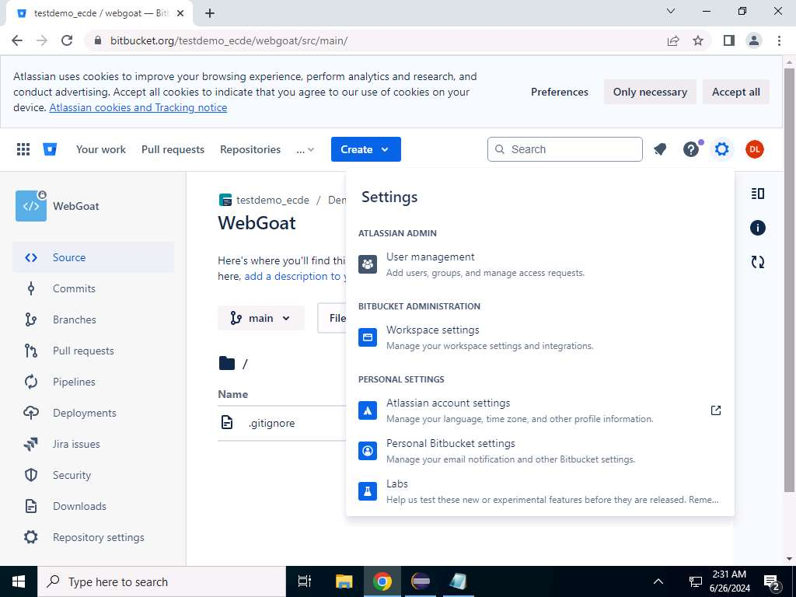
29. Now click on **App passwords** in the left pane.  
    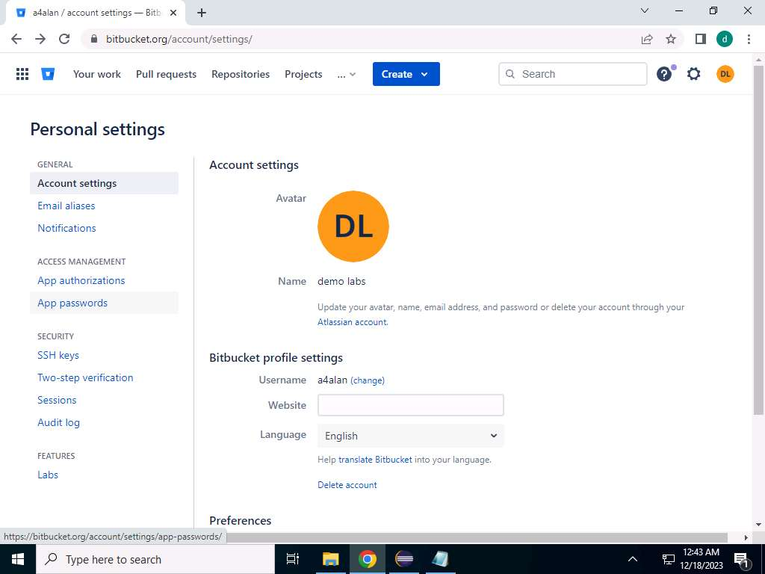
30. Click on **Create app password**.  
    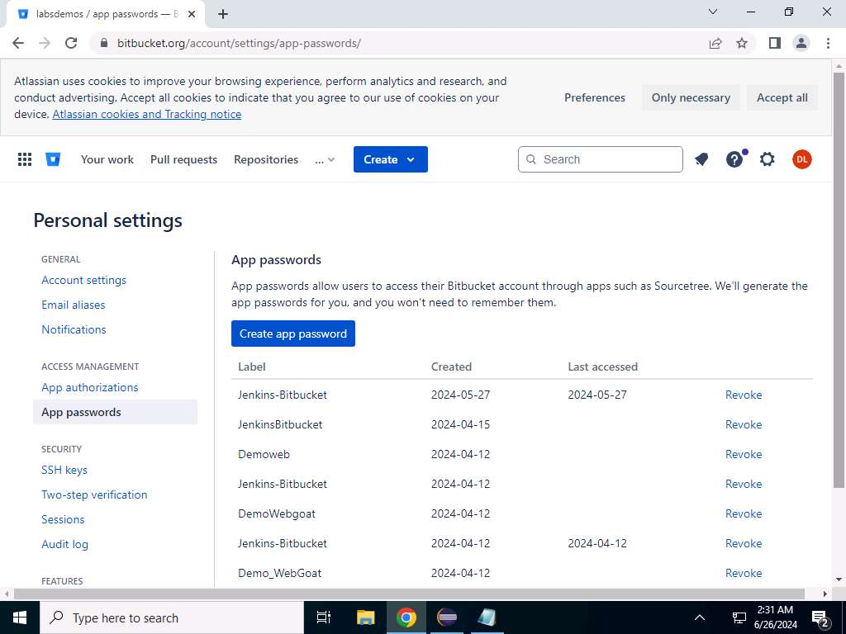
31. Under **Label**, type the name for token.  
    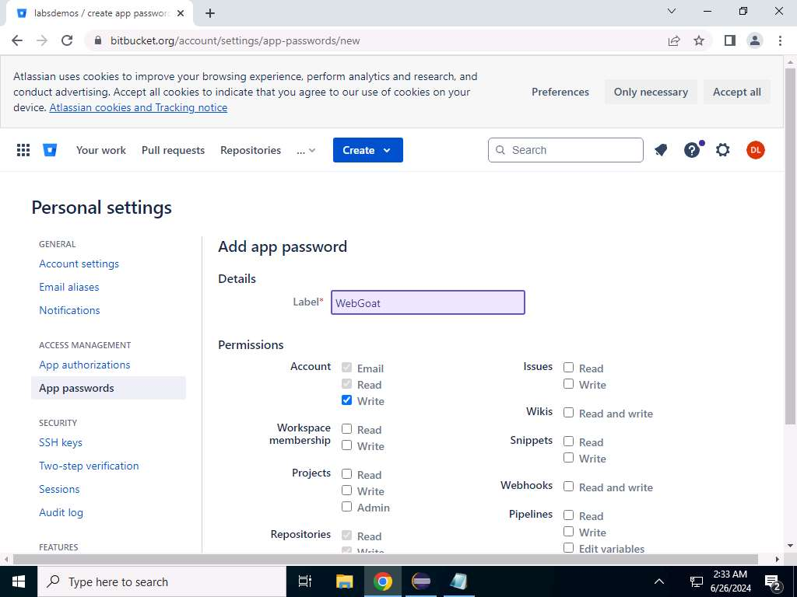
32. Select **Email, Read, Write** under **Account**.  
    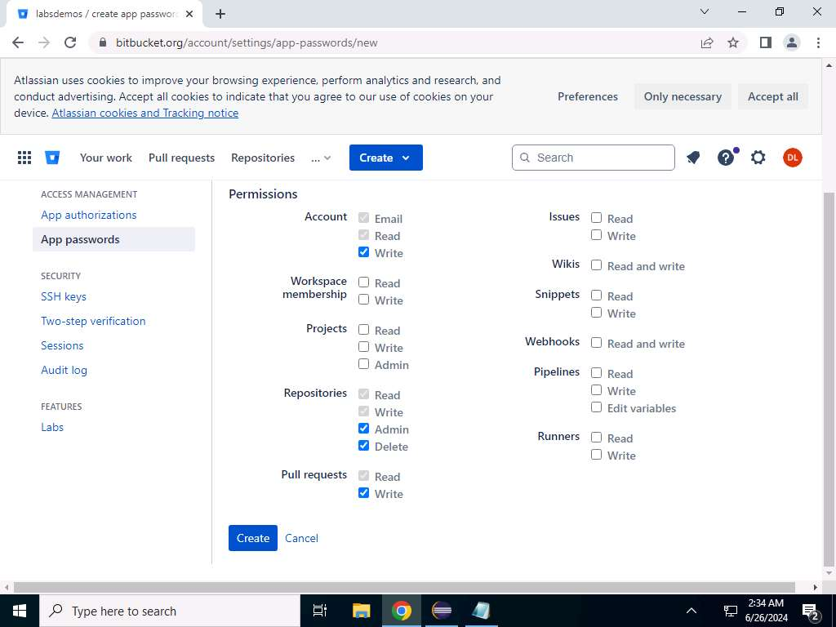
33. Under **Repositories**, select **Read, Write, Admin,** and **Delete**.  
    
34. Now select **Read, write** under **Pull requests**, and click on **Create**.  
    
35. Copy the password generated to Notepad.  
    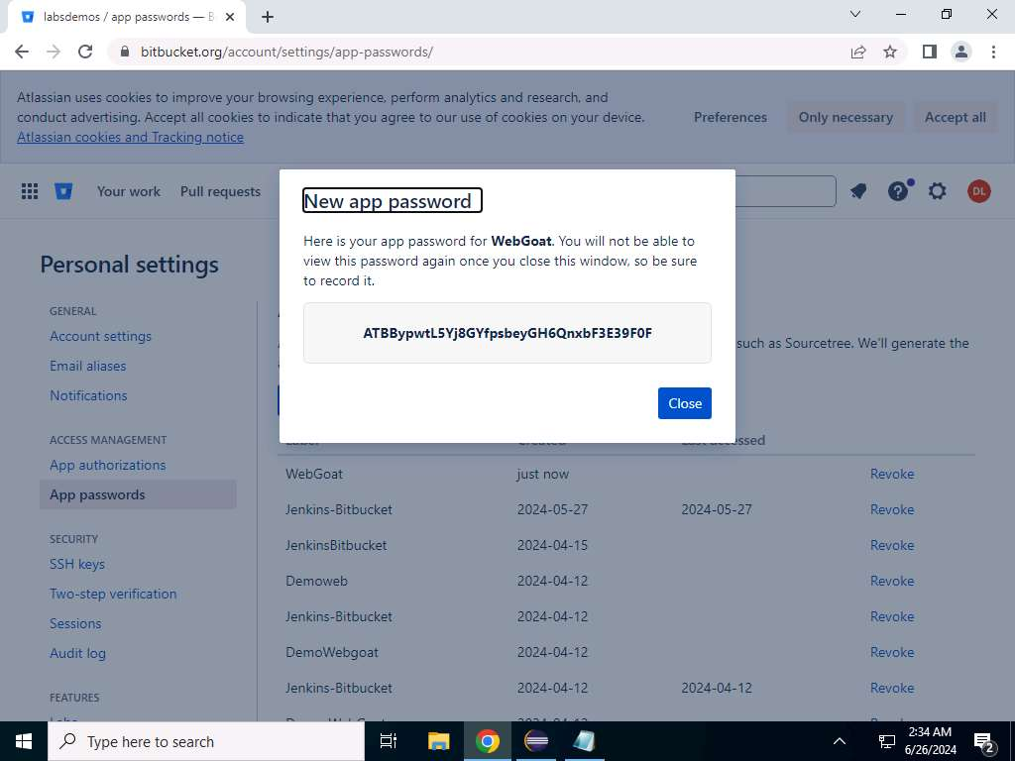
36. Now we will use the information generated to copy the project from Eclipse to Bitbucket at **step 27**.. Go to the **Eclipse** tab and paste the **URL** copied in the **URL** tab.  
    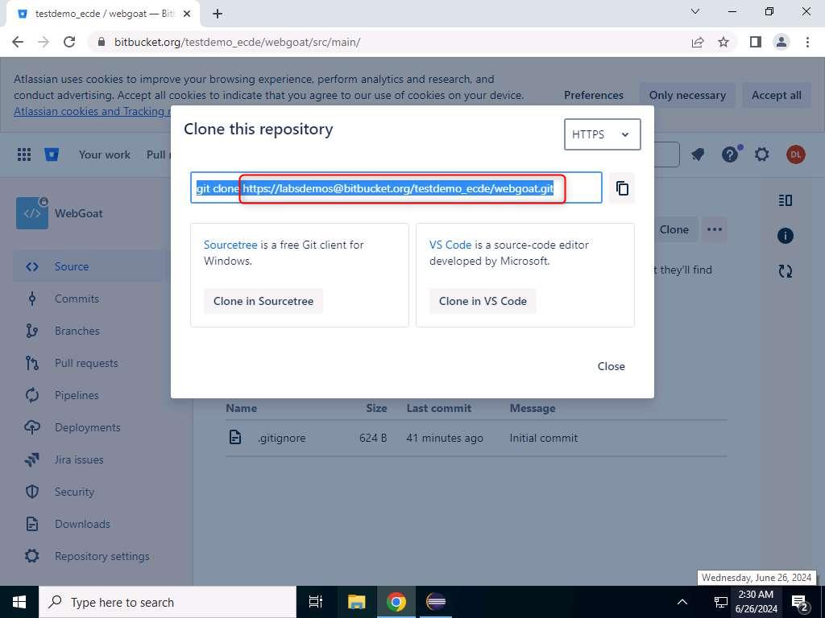 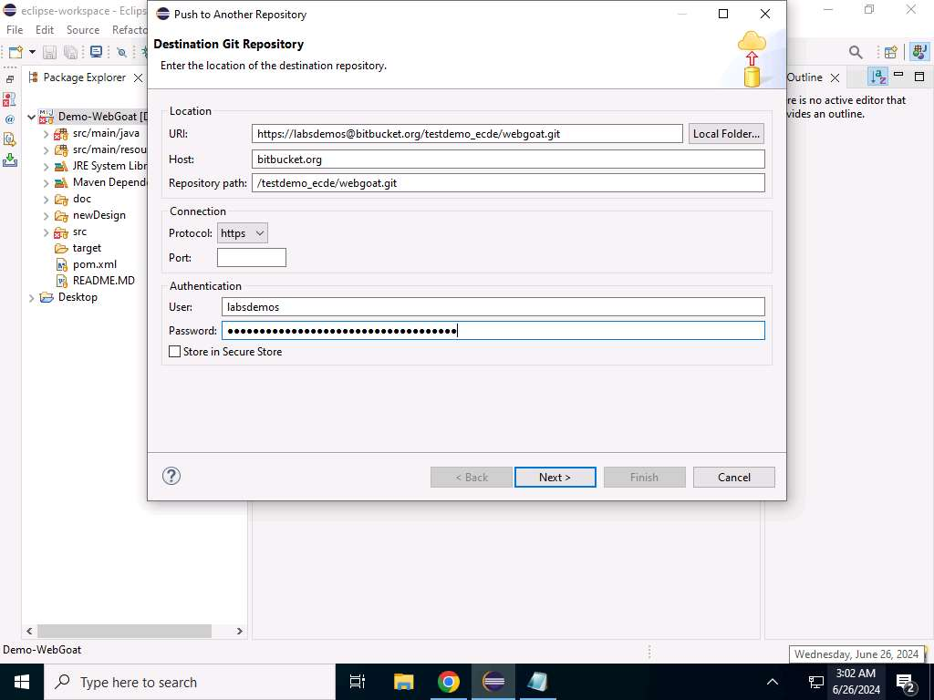
37. In **Host** type **bitbucket.org**.  
    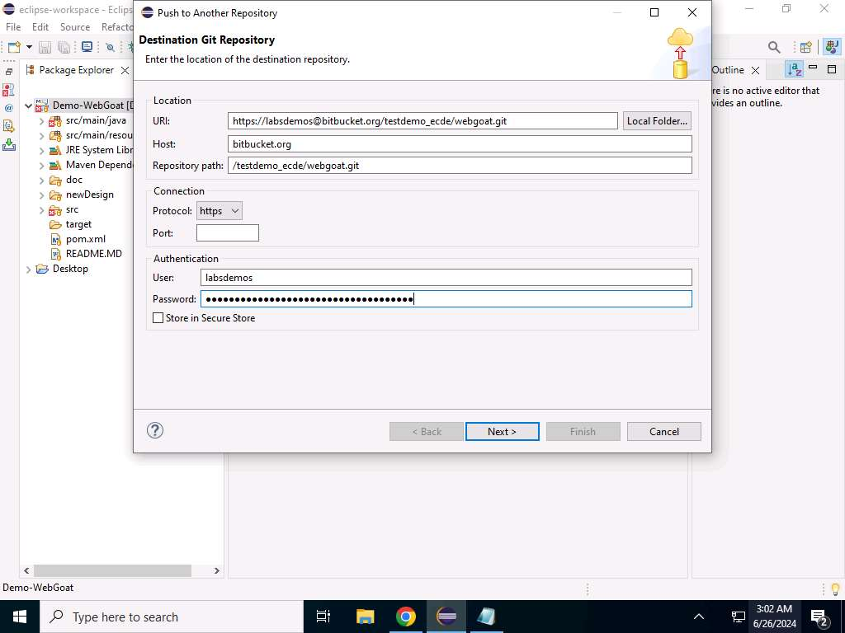
38. In **User**, type your username for Bitbucket.  
    
39. In **Password** field, paste the app password generated in Bitbucket and click on **Next**.  
    
40. Type **refs/heads/master** in the **Source ref**, **Destination ref**, and **Remote ref to delete** fields and click on the **Add spec** button.  
    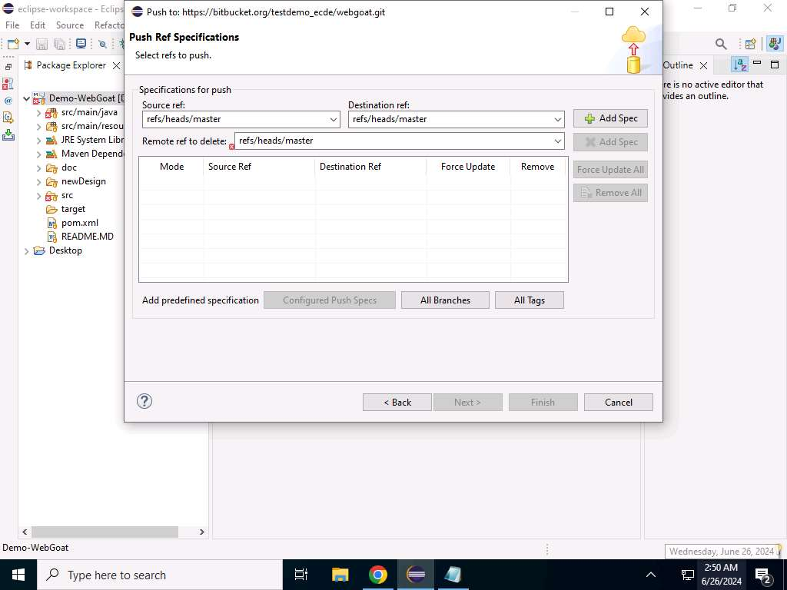
41. Now **Enable** the **Force Update** and click on **Next**.  
    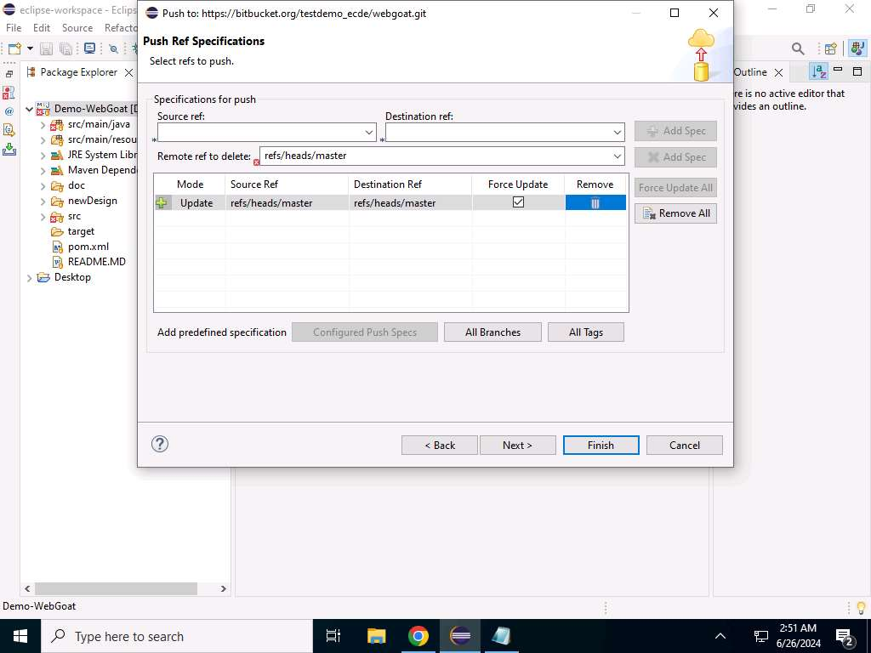
42. Now click on **Master -> Master** and click on **Finish**.  
    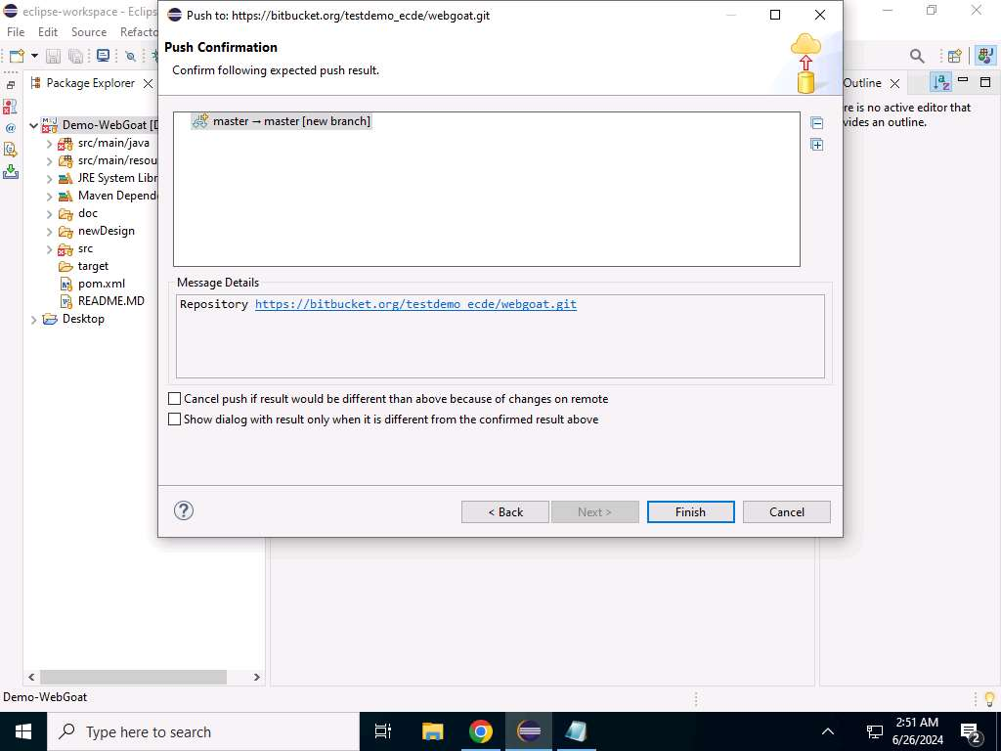
43. Now go to the Bitbucket tab and reload the page to view the project in the Source page.  
    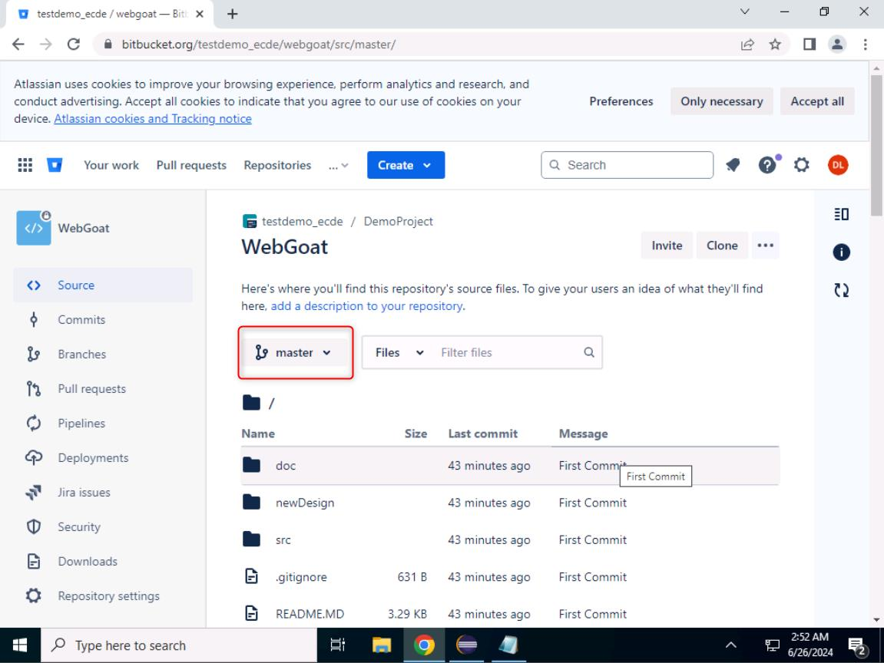
44. By using the above steps, a DevSecOps engineer can integrate Bitbucket with Eclipse.

**Assessment 1.1.1.1:**

Enter the Source, Destination, and Remote push reference specification used in the lab to copy the source code from Eclipse IDE to BitBucket.

refs/heads/master